1. library(ISLR)
2. attach(College)

College.rownames= rownames(College)

1. We use summary function

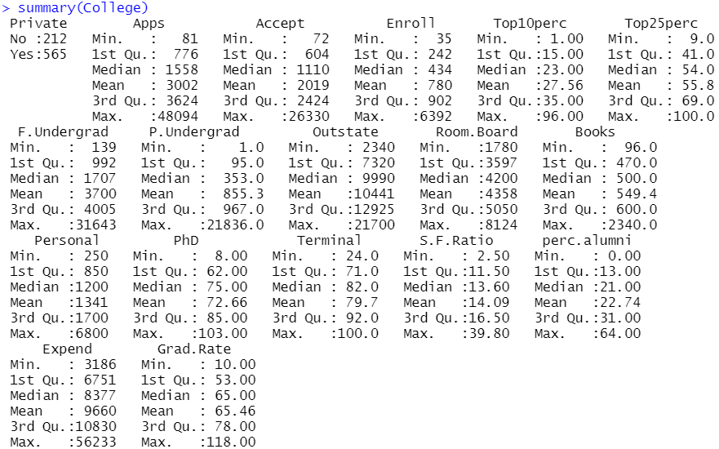

1. 

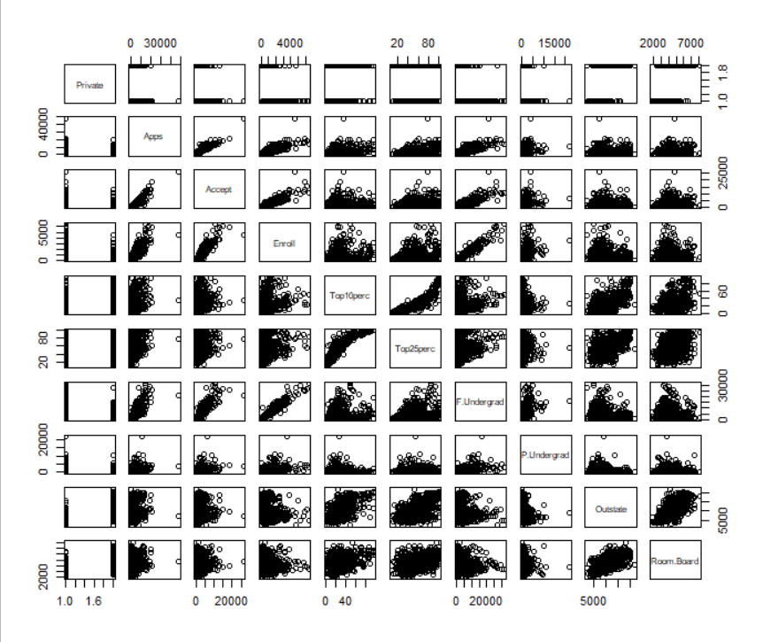

1. 

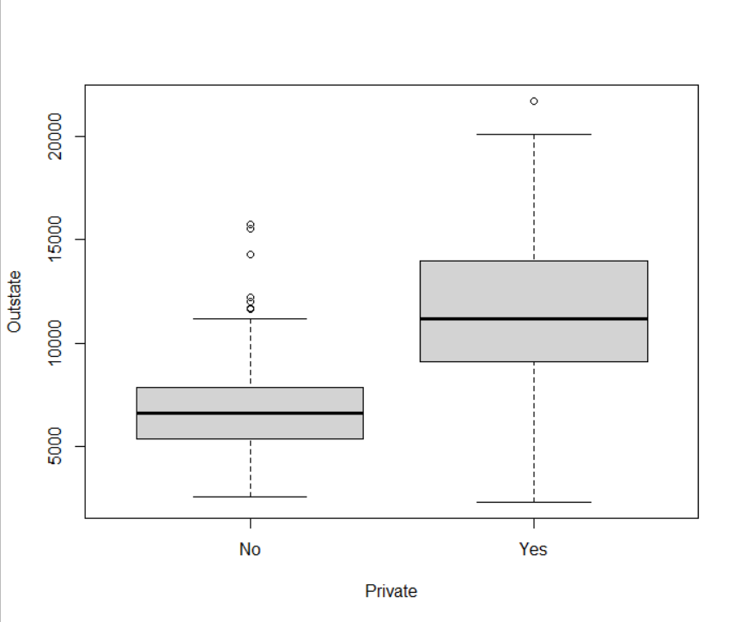

1. Here, first we crate a row with all “No”. then we replaced the Top10perc>50 by “Yes” and combined them with main data.

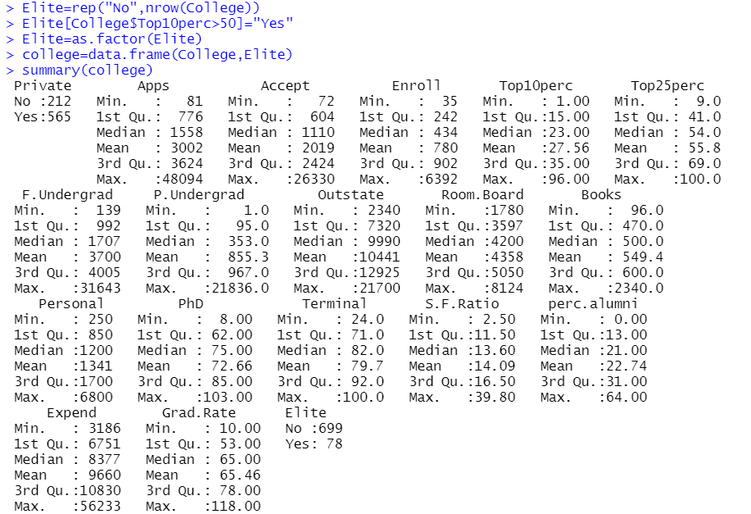



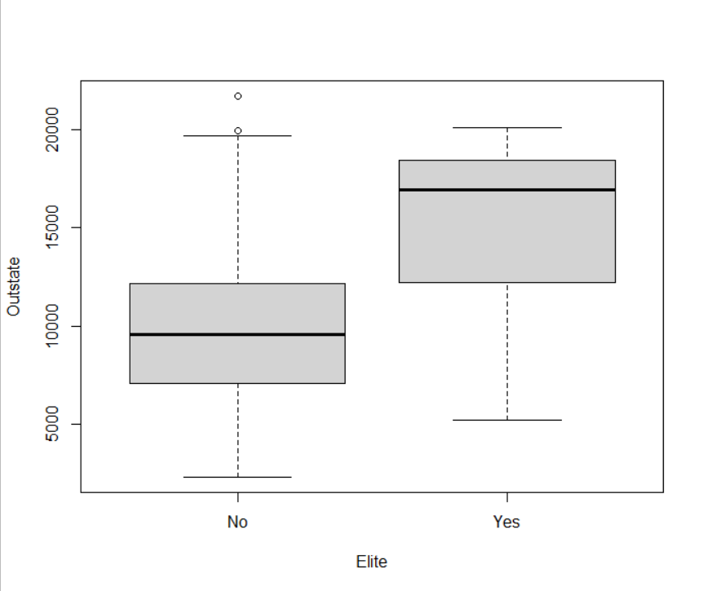

1. Now we create histogram. It is to be noted that 1st and 2nd histograms are same, only differing in number of bins.

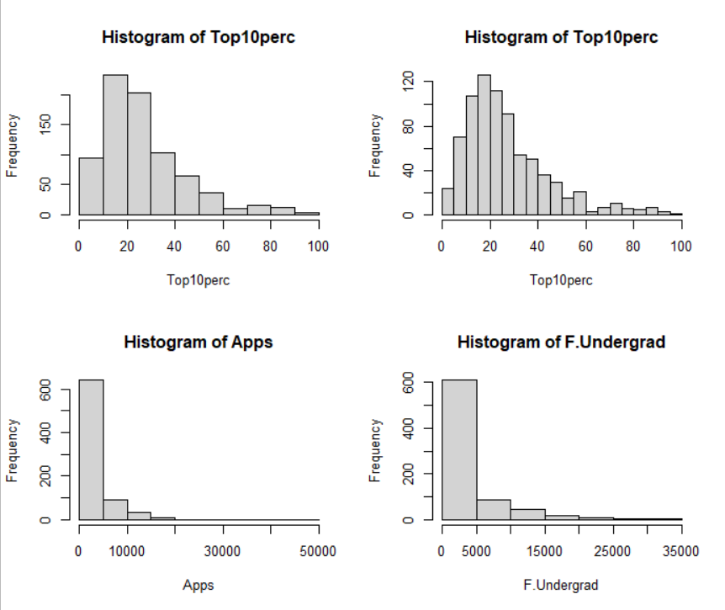

Histogram of Top10perc is positively skewed, implying, only a few universities got majority if their new students from this class. Histogram of apps is also positively skewed, implying, most of the universities received less than 5000 applications.

1. Now, we make a plot between student faculty ratio and undergraduate rate.



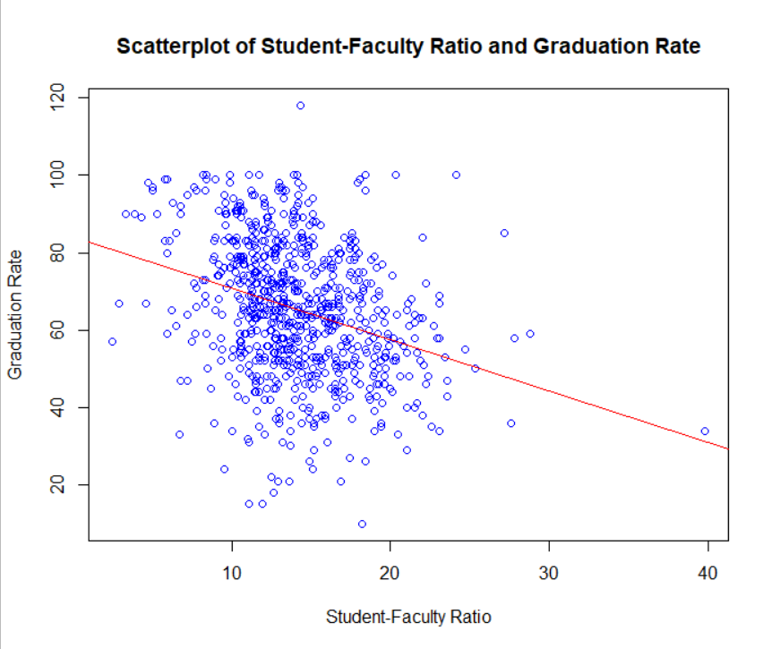

From the graph we can see that, as student-faculty ratio increases, graduation rate increases. Also, it is clear that, this data cannot be fitted assuming the underlying relationship as linear.